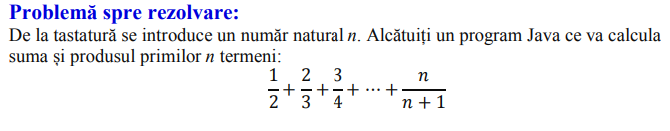

import java.util.Scanner;

public class Problema {

public static void main(String args []){

Scanner sc=new Scanner(System.in);

int n=sc.nextInt();

double S=0;

for (double i=1 ; i<=n ; i++) {

double p=i/(i+1);

S=p+S;

}

System.out.println(“Suma este: “+S);

Sc.close();

}

}

import java.util.Scanner;

public class Problema7A {

public static void main(String args []){

Scanner sc=new Scanner(System.in);

int n=sc.nextInt();

int S=0;

int P=1;

for (int i=1 ; i<=n ; i++) {

S=S+(2\*i-1);

P=P \*(2\*i-1);

}

System.out.println(P+”și“+S);

Sc.close();

}

}

import java.util.Scanner;

public class Problema7B {

public static void main(String args []){

Scanner sc=new Scanner(System.in);

int n=sc.nextInt();

int S=0;

int P=1;

for (int i=2 ; i<=n ; i++) {

S=S+(2\*i);

P=P\*(2\*i);

}

System.out.println(P+”și“+S);

Sc.close();

}

}

import java.util.Scanner;

public class Problema7C{

public static void main(String args []){

Scanner sc=new Scanner(System.in);

int n=sc.nextInt();

int S=0;

int P=1;

for (int i=1 ; i<=n ; i++) {

S=S+(3\*i);

P=P\*(3\*i);

}

System.out.println(P+”și“+S);

Sc.close();

}

}

import java.util.Scanner;

public class Problema7D {

public static void main(String args []){

Scanner sc=new Scanner(System.in);

int n=sc.nextInt();

int S=0;

int p=1;

for (int i=1 ; i<=n ; i++) {

S=S\*(4\*i);

P=P\*(4\*i);

}

System.out.println(P+”și“+S);

Sc.close();

}

}